Year 4 Shared Education Programme

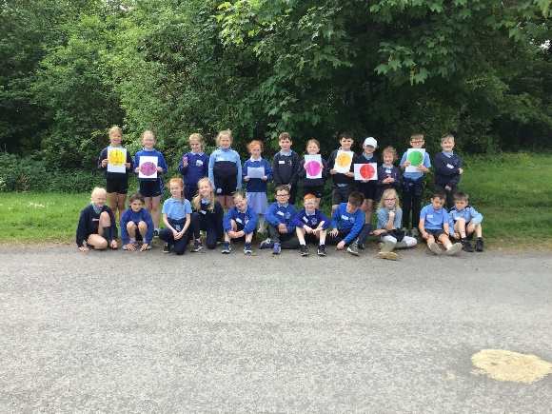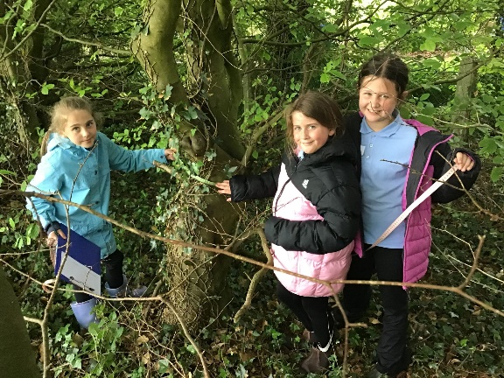

72 Pupils from Year 4 in Ballinamallard Primary School, St. Paul’s Primary School and Irvinestown Primary School have thoroughly enjoyed their shared lessons this year. Throughout the year we focused on the curriculum area of ‘The World Around Us’ and the pupils took part in 5 Outdoor Learning lessons linked with this area of the curriculum. We really enjoyed meeting together!
We were excited to spend our first morning in March together in Ballinamallard Primary School. We enjoyed icebreakers, making bird fruit kebabs, building bird nests and going on
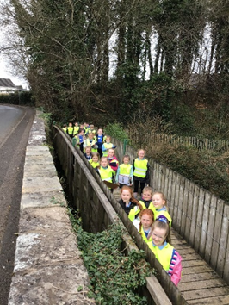
a river walk to the Mill Race spotting birds as we walked. We brought our bird feeders back to school to watch for a variety of birds in our school grounds. A great way to start our Shared Education journey!
In Irvinestown Primary, our focus was on Mini Beasts. We moved around a carousel of activities encouraging us to explore Mini Beasts and their surroundings. These activities were completed throughout the morning and we were grouped with friends from our own school and new friends too! We used iPads and the Just2easy programme to record information on different types of minibeasts and completed graphs based in the data.
We explored the school grounds to find different Mini Beasts, looking closely using magnifying equipment and identification charts to classify them. We explored the work of the artist James Brunt and created our own interpretations of his art using only natural resources and things found within the School Garden.
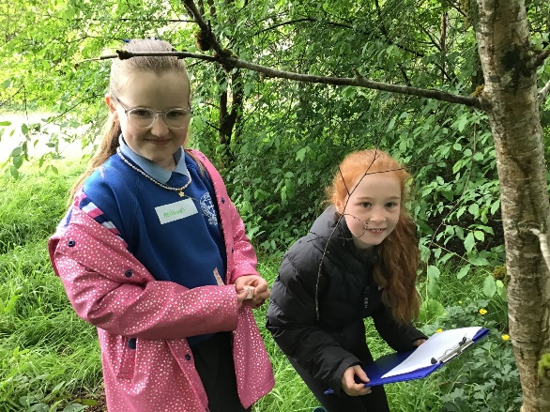
In St Paul’s Primary School our lessons focused on mindfulness, Literacy, and Forest School activities. The children had the opportunity to take part in a mindfulness lesson focusing on how to manage feelings of stress and anxiety through breathing exercises. Phonics was taught through nature, focusing on rhyme and rhythm. The children worked collaboratively during the den building lesson with lots of great discussions and problem solving taking place!
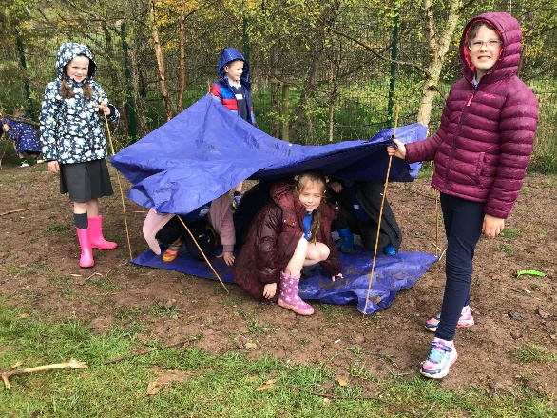
Our next visit was back to Ballinamallard Primary School, where we focused on trees and plants. Over the morning, we rotated around three stations where we used measuring tape to estimate the height and age of trees. In the forest area we enjoyed a scavenger hunt looking for signs of spring. Lastly, we looked at the trees and used a tree identification chart to spot different types of trees in the grounds. We used crayons to make leaf rubbings identifying which leaves belonged to the different trees. We were enthusiastic and focused on our learning.
We were excited to complete our shared lessons together exploring Necarne. It was such a great opportunity to visit this local resource.
We explored the grounds, looking for the colours of nature and identifying the natural plants and trees as we walked. Finally, we enjoyed playing together in the wonderful sunshine!

We have had a fantastic time this year learning together and making new friendships. We look forward to more shared experiences together in the future.
